

**SEMESTER 1 2024/2025**

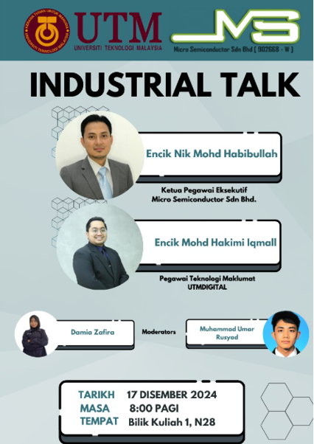

**INDUSTRIAL TALK REPORT**

**TECHNOLOGY AND INFORMATION SYSTEM SECP1513**

**SECTION : 5**

**GROUP : 7**

**GROUP MEMBER :**

|  |  |
| --- | --- |
| **NAME** | **MATRIX NO.** |
| **CHAN SIEW CHING** | **A24CS0057** |
| **CHING QI YAN** | **A24CS0235** |
| **LOOI YU XIANG** | **A24CS0107** |
| **UNG YII JIA** | **A24CS0310** |
| **YEOH HUEY TING** | **A24CS0315** |

The industrial talk was organized on 17th December 2024 at 8 am, located at N28 and moderated by Miss Damia Zafira and Mr. Muhammad Umar Rusyad. Two speakers were invited to this talk, who were Mr. Nik Mohd Habibullah, Chief Executive Officer of Micro Semiconductor Sdn. Bhd. and Mr. Mohd Hakimi Iqmail, an Information Technology Officer of UTMDIGTAL.

**Skills required by industry**Mr. Mohd Hakimi Iqmail, who is an alumnus of Universiti Teknologi Malaysia (UTM), introduced the organizational structure of UTMDIGITAL and shared his professional background. After graduating, he joined Okakichi Sdn Bhd in 2018, where he developed the game *Kingdom Ran.* In 2019, he started working at UTM Research Computing. He continued working at UTMDIGITAL in 2021, motivated by 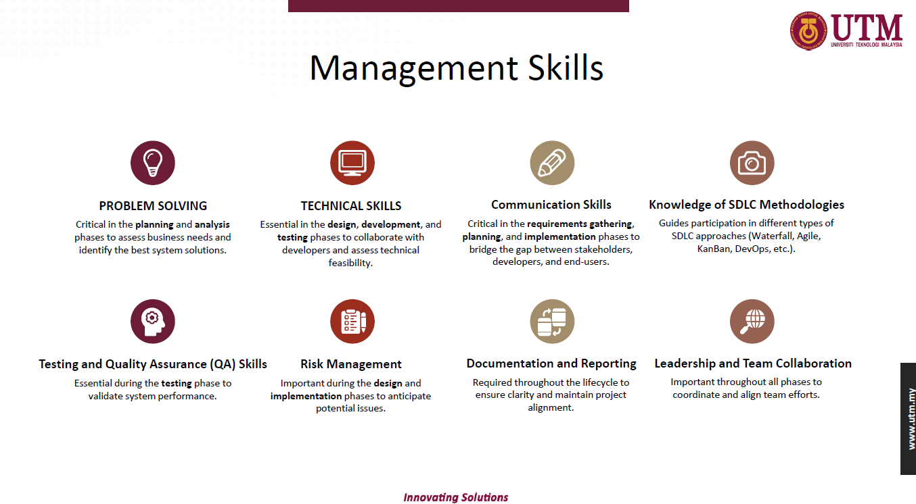his dedication to contributing to UTM.Technical Skill


Figure 2 Management Skills

Figure 1 Technical Skills

Next, Mr.Hakimi shared the skills needed to succeed in the IT field, which is technical and management skills. He highlighted the importance of mastering technical skills like C and C++ programming, version control for code management, and database designing that were desired by employers (Abraham et al., 2006, as cited in Mohd Adam Suhaimi et.al, 2012; Cheryl L. Aasheim et al., 2009). He also mentioned analytical and logical skills are important for solving problems by reducing steps and evaluating the important elements (Cheryl L. Aasheimet al., 2009).

Transitioning to management skills, Mr. Hakimi noted that having problem-solving skills in the planning and analysis phases can help address business needs and propose solutions (Cheryl L. Aasheim et al., 2009). He highlighted the role of technical skills in design, development, and testing to assess project feasibility and discussed the significance of SDLC methodologies (Cheryl L. Aasheim et al., 2009), such as Agile, DevOps and DevSecOps. He also mentioned that leadership, teamwork, and empathy can help foster collaboration and achieve goals. The session ended with a Question-and-Answer session.

Next, Mr. Nik Mohd Habibullah introduces himself that he is a 2005 UTM graduate who has worked with companies like NI Solution and Datsini. In 2019, he launched *GetMeHired*, a platform helping students and professionals create CVs and secure job offers at renowned companies such as Intel, Samsung, Celcom, and IBM.

He emphasized the importance of self-exploration, noting that over half of people work outside their degree field. He also stressed securing internships, especially in Year 3, as employers often prefer candidates with recommended experience (Cheryl L. Aasheim et al., 2009).

**Job Application Flow**



Figure 3 Job Application Flow

The IRPA method is a strategic approach to job applications, emphasizing soul-searching. We should identify our desired job and industry, no matter if it is system development or education. Then, do research on the company’s goals and KPIs to prepare thoroughly. Prepare to craft a strong CV, portfolio, and resume. Finally, leverage job portals like LinkedIn and JobStreet to connect with employers.

**Basic Skills Required for Computer Science**

|  |  |  |
| --- | --- | --- |
| Category | Important Terms | Tools and Software |
| Programmer/System Development | * Algorithms * DevOps | * Git & GitHub * Visual Studio Code |
| System Network and Security | * Firewall * Encryption | * Wireshark * Cisco Packet Tracer |
| System Analyst | * Gap Analysis * Prototyping | * Lucidchart * SmartDraw |

Table 1 Basic Skills Required for Computer Science

**Reflection**

Yii Jia: I will equip myself with management and technical skills, such as analytical thinking during my studies.

Huey Ting: I understand how important problem-solving, programming expertise, and effective teamwork are for achieving success in development and project management roles.

Siew Ching: We should start applying for jobs or internships early, as building connections through internships at well-known companies can give us an edge.

Yu Xiang: While studying computer science, it is important to enhance our technical skills and develop other abilities and broaden our knowledge to grow holistically.

Qi Yan: It is important to develop technical and management skills in a way that aligns with our style and pace to fulfil our dreams as well as reflect our values and aspirations.

**References**

Abraham, T., Beath, C., Bullen, C., Gallagher, K., Goles, T., Kaiser, K. and Simon, J. (2006). IT workforce trends: implications for IS programs, *Communications of the Association for Information Systems*, Vol. 17, pp. 1147-70.

Cheryl L. Aasheim, Lixin Li, Susan Williams. (2009). Knowledge and Skill Requirements for Entry-Level Information Technology Workers: A Comparison of Industry and Academia. *Journal of Information Systems Education, Vol. 20(3),* <https://jise.org/volume20/n3/JISEv20n3p349.pdf>

Mohd Adam Suhaimi, Muhammad Rabiul Hasan, Husnayati Hussin and Asadullah Shah. (2012). Information and communication technology workforce employability in Malaysia.   
*Campus-Wide Information Systems, Vol. 29(2),* <https://www.emerald.com/insight/content/doi/10.1108/10650741211212340/full/html?skipTracking=true>